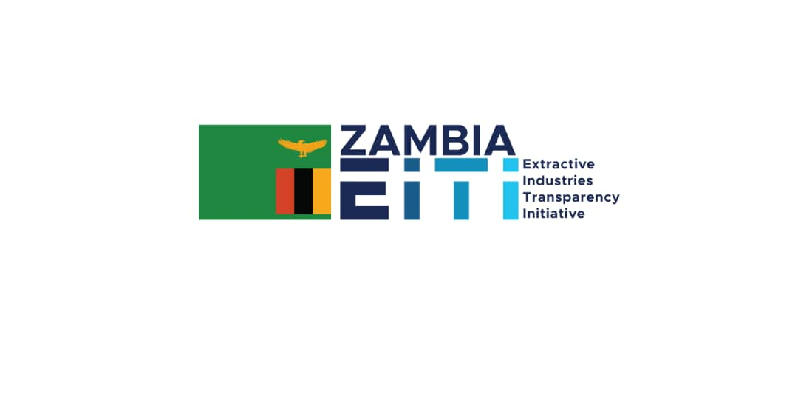

Validation Comments by the Zambia EITI Council

Public debate (Requirement #7.1)
ZEITI is not exceeding all recommendations of this requirement as it does not yet provide sufficient evidence for catering to differences in age, gender, ethnicity, languages, or others.
Comment: ZEITI outreach includes outreach to local communities. In these local communities, local languages are used to engage community members. ZEITI (or CSOs) recently held Mining Indabas in various mining communities. These meetings are conducted in local languages and ofcourse in English to cater for participants who don't speak the local dialect. Please see the email invites from organisers below here:
Dear Colleagues,

Greetings,find attached an invitation letter for multi stakeholder information sharing dialogue on Corporate Social Responsibilty focussing on Agriculture and Education implemented by the Trident Foundation Kalumbila Minerals.Note that the meeting wil be held at AMIS or rather Lumwana Premier Resort on Tuesday the 19th of October 2021.Refer to the program attached for more information regarding the Agenda and Objectives
regards
Mwiya

Mwiya Mwandawande

National Coordinator
Extractives Industry Transparency Alliance
Plot Number 10487, Manchichi,Road
Olympia Park ,Lusaka.

Contact Number: 0975 744 106

As you might have noticed from the above, Civil society outreach intentionally aims to ensure gender balance not just in attendance but also in actual engagement or participation during meetings. See also attachment on the 2019 meeting.

Contracts (Requirement #2.4)
Comment: With respect to Validation of this requirement, the MSG made reference to the 2021 Validation guide which has 2 phases of Validation.
Required disclosures: Phase 1: 1 January 2021-1 January 2022
The Validation is expected to document:
- Whether the government’s policy on contract transparency has been disclosed. This should include a description of whether legislation or government policy addresses the issue of disclosure of contracts and licenses, including whether it requires or prohibits disclosure of contracts and licenses. If there is no existing legislation, an explanation of where the government policy is embodied should be included, and the multi-stakeholder group should document its discussion on what constitutes government policy on contract disclosures and any government reforms that are planned or underway (2.4.c). ZEITI clearly documents government policy on contract transparency p.64 of the 2019 EITI Report.
- Whether the MSG has provided an explanation for the deviation, where disclosure practice deviates from legislative or government policy requirements concerning the disclosure of contracts and licenses (2.4.c.iii). Disclosure practice does not deviate from government policy requirements
- For contracts and licenses granted, entered into and/or amended after 1 January 2021 that are not covered by legal or practical barriers requiring long-term solutions, Validation will assess whether the country has comprehensively disclosed all such contracts and licenses in full including relevant annexes, addendum or rider (2.4.a in relation to 2.4.d) Contracts and licenses granted, entered into and or amended after 1 January 2021 ARE covered by legal and practical barriers requiring long term solutions. Zambia, therefore, did not comprehensively disclose all such contracts and licenses in full.
- For contracts and licenses granted, entered into and/or amended after 1 January 2021 that are covered by legal and practical barriers requiring long-term solutions such as legal amendments, Validation will assess the extent to which (1) the MSG has documented and explained these barriers (2.4.c.ii) (2) the MSG has agreed and published a plan with a clear time frame reflected in work plans addressing any barriers to comprehensive disclosure (2.4.b) (3) the extent to which all constituencies in the MSG are actively implementing their plan to address these barriers including the board-recommended approach of asking companies to waive confidentiality provisions (Board decision 2020-69/BC-295).
Comment:
- ZEITI’s workplan has activities that are aimed at addressing barriers to comprehensive disclosure. Output 4 of the 2021-2022 workplan is on the Draft Transparency and Accountability Bill. ZEITI has chosen to focus on the Bill as Section 23 currently provides that the concessions, contracts and licenses relating to an extractive industry.
- Output 5 of the workplan is also focused on disclosing license information on the MMMD portal. Under this output there are planned activities relating to engaging the MMMD, using the mainstreaming feasibility study as a gap analysis on license disclosures; and monitoring progress.
- ZEITI is also currently undertaking a contracts disclosure mapping exercise (see attached ToRs).
- The above represents a cogent plan to address barriers to disclosure and the MSG is engaged in rolling out the plan.
- Whether the MSG has documented disclosures of contracts and licenses in practice. For contracts executed before 1 January 2021, such disclosures are encouraged but not required and should not be considered in assessing compliance with the EITI provisions (2.4.a). The MSG documented disclosures of contracts and licenses in practice. See sect 4.4.2.1 of the 2019 EITI Report
· Whether an overview or a list of all active contracts and licenses, including exploration contracts, is publicly available, indicating which contracts and licenses are publicly available and which are not. Comment: ZEITI is also currently undertaking a contracts disclosure mapping exercise(see attached ToRs)
- Where contracts and licenses are disclosed, whether the implementing country has published information on how these contracts and licenses can be accessed (2.4.c.ii). Contracts are not currently disclosed

Beneficial ownership (Requirement #2.5)
MSG has published an assessment of the comprehensiveness and reliability of beneficial ownership disclosures to date from all companies holding or applying for extractive licenses (i.e. not only of material companies included in the scope of EITI reporting in accordance with EITI Requirement 2.5.c). In addition, the PACRA's company register and portal does not provide the name of the stock exchange where publicly-listed companies (or their wholly-owned subsidiaries) are listed. Lastly, legal ownership of extractive companies is only partially disclosed by Zambia EITI, and while the PACRA registry contains some information on legal owners, for most companies it is not possible to ascertain that all legal owners and their respective shares have been disclosed.
Comment:
The MSG was guided by the 2021 Validation guide which indicates that assessment of this requirement would be done in Phases.
Required disclosures (Phase 1: January 2020 – 31 December 2021)
The Validation is expected to document whether:
- The MSG has agreed an appropriate, publicly available definition of the term beneficial owner that is aligned with Requirement 2.5.f.i, takes international norms and relevant national laws into account, includes ownership threshold(s) and specifies reporting obligations for politically exposed persons as defined by the MSG or applicable regulations (2.5.f) Addressed
- There are laws, regulations or policies in place to back establishing and maintaining a public register of beneficial owners, including those of corporate entity(ies) that apply for, operate or hold a participating interest in an exploration or production oil, gas or mining license or contract (2.5.a, recommended only and should not be considered in assessing compliance with the EITI Standard); Addressed
- The government’s policy and multi-stakeholder group’s discussion on disclosure of beneficial ownership is documented, including details of the relevant legal provisions, actual disclosure practices and any reforms that are planned or underway (2.5.b); Addressed
- The implementing country has requested beneficial ownership information to be publicly disclosed by corporate entity(ies) that apply for, or hold a participating interest in an exploration or production oil, gas or mining license or contract and whether the legal framework backs the request for public disclosure (2.5.c); Addressed
- The requested information includes the identity(ies) of their beneficial owner(s), including nationality, country of residence, and identification of politically exposed persons, the level of ownership and details about how ownership or control is exerted; (2.5.c-d) Addressed
- Any corporate entity(ies) that apply for, or hold a participating interest in an exploration or production oil, gas or mining license or contract have disclosed the information; Addressed. The understanding is that some/any corporate entities have disclosed BO information- not all.
- The MSG had assessed and documented gaps or weaknesses in disclosure of beneficial ownership information, including an assessment of the materiality of omissions and the reliability of beneficial information, and whether the government or MSG agreed and documented plans to overcome the identified challenges (2.5.c); Sec 4.5.2.1 documents some gaps /weaknesses in disclosure of BO information.
- The relevant government entity or the MSG has established an approach for participating companies to assure the accuracy of the beneficial ownership information they provide (2.5.e); Addressed
- For publicly listed companies, including wholly-owned subsidiaries, the name of the stock exchange has been disclosed and a link included to the stock exchange filings where they are listed, either in the public register on in the EITI Report (2.5.f); Addressed but with some gaps
- Information about legal owners and share of ownership of applicable companies is publicly available. (2.5.g) Addressed
Production (Requirement #3.2)
Since the previous Validation production values of Amethysts, Dolomites and Quartz have not been provided for 2019. ZEITI has also not performed additional disclosures as in past years to cover additional commodities missing from EITI reports.
- The official position of the government is that they dont assign any values to industrial minerals because the sector is largely informal.
- The assignment of values will only be done once the sector is fully understood by the government. The values at the moment can only be ascertained after a sale in which all these sales happen informally.

Exports (Requirement #3.3):
However, export volumes and values of different gemstones and industrial minerals and have not been provided for individually nor has it been for cement or limestone products.

The values are only collected by ZRA after a sale or auction. This information is reported for purposes of calculating tax liability as opposed to understanding the aggregate values. In some cases ZRA does its own calculations. See attached documents.

Comments done on the report by some MSG Members

- Finally, Zambia EITI documentation – and their participation in an on-going study related to production and export monitoring systems – has helped uncover issues in the government’s Mineral Output Statistical Evaluation System (MOSES), which currently only covers base and precious metals. This presents a challenge for Zambia to ensure comprehensive disclosure of production and export volumes and values for other extractive commodities, industrial and energy minerals, as well as for gemstones.(MOSES is not a straightforward system to use and will be difficult to extend to small and medium scale operators in its current form. It is further complicated by internal algorithm errors which have at times double-counted copper production from different processes in operation at an individual site leading to overstatement of production from certain projects and therefore national production. While such issues have been pointed out by the project owners, GRZ is yet to correct them. Refinement of MOSES and its practical extension to cover the full range of commodities produced in Zambia combined with its official adoption by Government as the sole source of production data is fundamental to ZEITI and should form a key aspect of developing credible systematic disclosure). P.8. of the draft report.

- In conclusion, license and contract transparency faces legal barriers in Zambia. However, the ZEC and ZEITI do not yet have a clear plan for disclosing the full text of licenses granted or amended from 1 January 2021. Even with some limited activities highlighted in Zambia’s 2020-2021 Workplan, it does not address the identified challenges and barriers to public disclosure as identified above. It is also evident that a clear plan was not in place by the time of publication of the 2019 EITI Report, as a key recommendation in table 15 is to develop and implement such a plan. At the time of writing, Zambia EITI has commissioned a study which will explore how Zambia could approach public disclosure of the full text of all licenses and contracts in the future, through developing a plan in order to address the legal and practical gaps. To the best of my knowledge there are no individual contracts attached to mining rights in Zambia since the abrogation of the Development Agreements in 2008. The conditions of grant of a licence as attached to the licence certificate form the contract and list the obligations of the holder of a mining right. The Conditions of Grant of all different mining and non-mining rights are given in full in the Third Schedule of SI 7 of 2016, General Regulations. Disclosure should therefore be simple. That said, hydrocarbon licences and contracts need further investigation. P. 24 in the draft report.

- On project level reporting, at the moment in Zambia, taxes are reported using the “Tax address” which is the Tax Payer Identification Number (TPIN). Therefore, it so happens that a particular mining company will have several projects (Mining licence areas) under its TPIN. When reporting the tax activities for a particular tax type, this has to be done under the TPIN and whence forth the tax returns and consequently the tax administration system is designed as such. To change the reporting format from using Tax addresses to using project level reporting will ultimately require substantial changes to the tax returns, tax administration system and potentially to the tax law. This will require time and financial resources.

